**INTRODUCTION TO COMPELX SIGNALS IN MATLAB**

**LAB # 06**



**Spring 2022**

**CSE301L Signals & Systems Lab**

Submitted by: **Ebtihaj Abdullah**

Registration No. : **20PWCSE1885**

Class Section: **A**

“On my honor, as student of University of Engineering and Technology, I have neither given nor received unauthorized assistance on this academic work.”

Student Signature: ______________

Submitted to:

**Engr. Durr-e-Nayab**

Wednesday, June 1, 2022

**Department of Computer Systems Engineering**

**University of Engineering and Technology, Peshawar**

## Lab Objective(s):

Objectives of this Lab are;

* Generating Sinusoids
* Addition of Sinusoids with Variation in Parameters and their Plots
* Linear Phase Shift Concept When Dealing With Sum of Sinusoids

## Task # 01:

Generate the 1x10 row vector v whose i‐th component is cos (iπ/4).

**Problem Analysis:**

Vectors are important in wave generation and study.

**Algorithm:**

* Take in vector parameters as given in problem statement.
* Plot the vector.

**Code:**

*for i=1:10*

*Vec(i)=cos(i*(pi/4));*

*end*

*figure*

*plot(i,Vec,'--','linewidth',2)*

*xlabel('Sample Number')*

*ylabel('Signal Amplitude')*

**Code SS:**

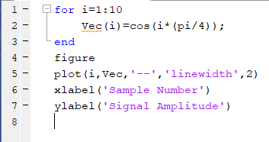

**Output / Graphs / Plots / Results:**

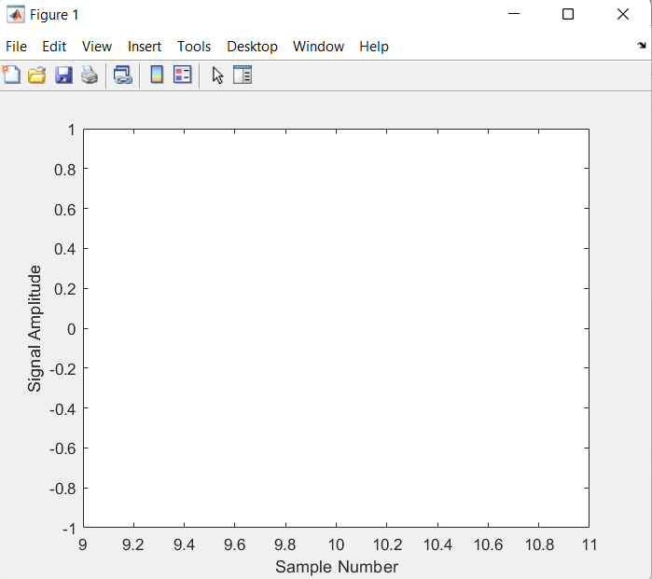

**Discussion and Conclusion:**

We can generate vectors in MATLAB

## Task # 02:

Write matlab code that draw graphs of sin (nπx) on the interval ‐1≤x≤1 for n = 1, 2, 3, …, 8.

**Problem Analysis:**

We need wave simulation for its study. We can simulate and generate waves using MATLAB.

**Algorithm:**

* Take in wave parameters.
* Plot the wave.

**Code:**

*x=1;*

*for n=1:10*

*V(n)=sin(n*(pi*x));*

*end*

*n=1:10;*

*figure*

*plot(n,V,'-m')*

**Code SS:**

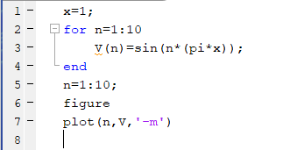

**Output / Graphs / Plots / Results:**

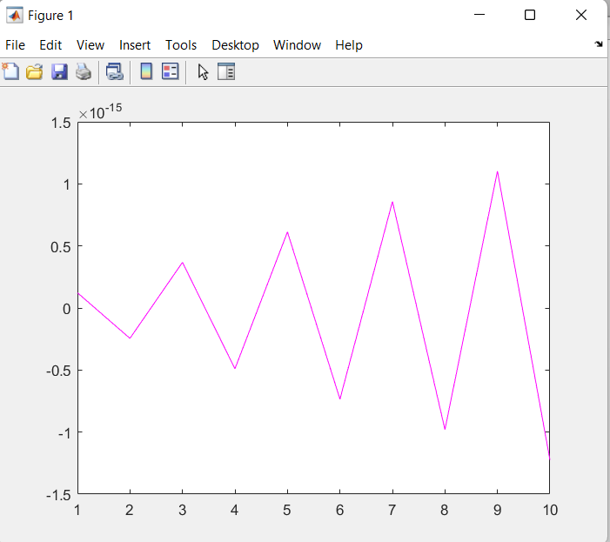

**Discussion and Conclusion:**

## We can simulate and generate waves using MATLAB

## Task # 03:

Given the signal exp(‐x)sin(8x) for 0≤x≤2π, plot its continuous‐time and discrete‐time representations. Use subplot and label properly.

**Problem Analysis:**

Continuous time and discrete time signals are the core concepts of signals and systems.

**Algorithm:**

* Enter signal parameters.
* Plot the signals.

**Code:**

*for x=-1:2*pi*

*V(x)=exp(-x)*sin(8*x);*

*end*

*x=0:2*pi;*

*figure*

*subplot(2,1,1)*

*plot(x,V,'--')*

*title('Continuous time')*

*subplot(2,1,2)*

*stem(x,V)*

*title('Discrete time')*

**Code SS:**

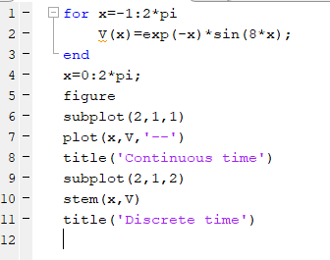

**Discussion and Conclusion:**

We can plot cont. time and disc. Time signals in MATLAB.

## Task # 04:

Modify the example given in topic 6.2 to generate a sine wave with phase shift of +pi/2. Then plot a cosine wave of same frequency, amplitude, and phase shift of 0 in another subplot. Compare both the signals and determine the relationship between the two.

**Problem Analysis:**

We may need different/same characteristic sine and cosine waves for our different operations. We can do that in MATLAB.

**Algorithm:**

* Input the parameters of the sinewave.
* Pass these parameters into the formula.
* Change parameters to adjust for cosine wave
* Subplot these waves

**Code:**

*clc*

*clear all*

*close all*

*t=-3:1/1000:3;*

*f=1; % fundamental frequency*

*A=3; % amplitude*

*phase=pi/2;*

*X1=A*sin(2*pi*f*t+phase);*

*subplot(2,1,1)*

*plot(X1,'-m')*

*title('Sine wave')*

*phase=0;*

*X2=A*cos(2*pi*f*t+phase);*

*subplot(2,1,2)*

*plot(X2,'-m')*

*title('Cosine wave')*

**Code SS:**

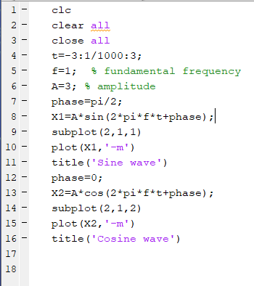

**Output / Graphs / Plots / Results:**

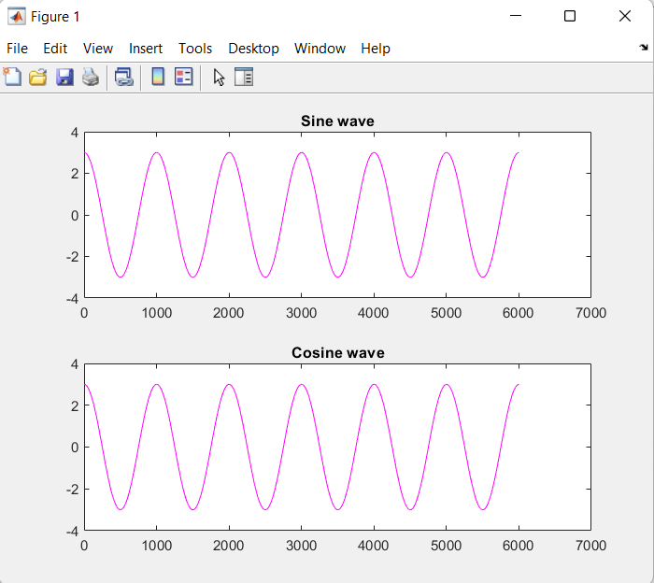

**Discussion and Conclusion:**

Generating continuous sinousoidal waves in MATLAB is possible.

## Task # 05:

Write a program to generate a continuous‐time sine wave of frequency 3 Hz, positive phase shift of pi/2, and amplitude of 5. Also generate a continuous‐time cosine wave of frequency 3 Hz, amplitude of 5, and phase shift of 0. Plot the two signals on separate subplots and properly label them. Determine the relationship between the two signals

**Problem Analysis:**

We may need different characteristic sine waves for our different operations. We can do that in MATLAB.

**Algorithm:**

* Input the parameters of the sinewave.
* Pass these parameters into the formula.
* Subplot these waves

**Code:**

*t=-1:1/100:1;*

*f=3;*

*phase=pi/2;*

*A=5;*

*s1=A*sin(2*pi*f*t+phase);*

*subplot(2,1,1)*

*plot(t,s1);*

*title('Continuous sine wave')*

*phase=0;*

*s2=A*sin(2*pi*f*t+phase);*

*subplot(2,1,2)*

*plot(t,s2);*

*title('Continuous cosine wave')*

**Code SS:**

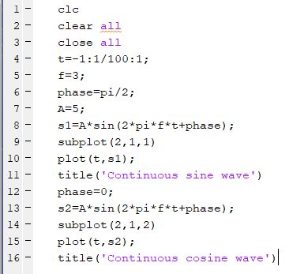

**Output / Graphs / Plots / Results:**

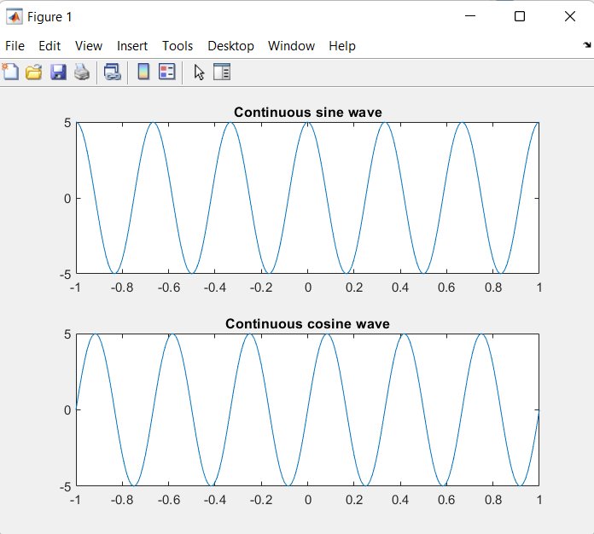

**Discussion and Conclusion:**

Generating continuous sinousoidal waves in MATLAB is possible.

## Task # 06:

Write a general program that takes ‘n’ sinusoids from user of same frequency, amplitude, and phase. Plot the individual sinusoids & the resultant using subplot function on same figure. Do perform proper labeling. Note: Take the amplitude, frequency, and phase given in example of case 1. Run the code for different values of n and state the result on paper

**Problem Analysis:**

We often need to compare various sinusoids with varying frequency. We can do that in MATLAB.

**Algorithm:**

* Take in no, of sinousoidals.
* Input their varying parameters.
* Create these sinousoidals and subplot them.

**Code:**

*input_num=input('Enter number of sinuosoids:');*

*x1=0;*

*t=0:10;*

*for n=1:input_num*

*f=3;*

*A=5;*

*phase=0;*

*x=A*sin(2*pi*f*t+phase);*

*subplot(input_num+1,1,n)*

*plot(t,x)*

*title('Input Sinosoid')*

*x1=x1+x;*

*grid;*

*end*

*subplot(input_num+1,1,n+1)*

*plot(t,x1)*

*title('Resultant Sinusoid')*

**Code SS:**

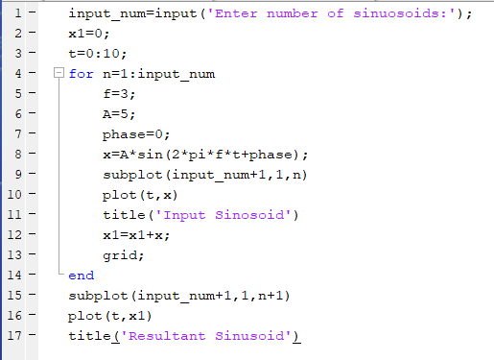

**Output / Graphs / Plots / Results:**

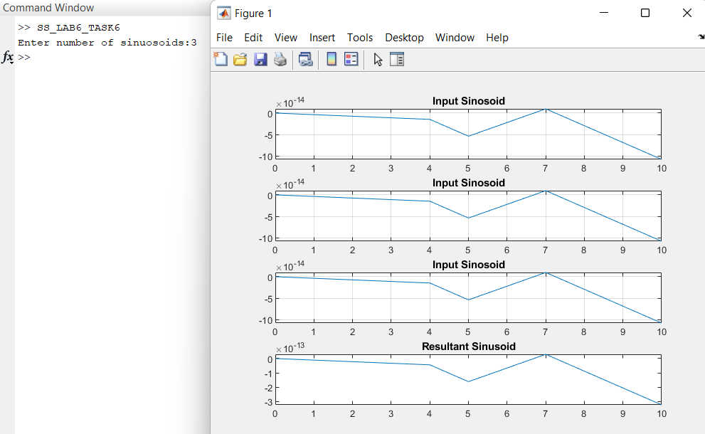

**Discussion and Conclusion:**

Hence we can compare sinousoidals in MATLAB.

## Task # 07:

Write a general program that takes ‘n’ sinusoids from user of same frequency and phase with varying amplitudes. Take amplitude from user on run time. Plot the individual sinusoids & the resultant using subplot function on same figure. Do perform proper labeling. Note: Take the amplitude and frequency given in example of case 2. Run the code for different values of n and state the result on paper.

**Problem Analysis:**

We often need to compare various sinusoids with varying frequency. We can do that in MATLAB.

**Algorithm:**

* Take in no, of sinousoidals.
* Input their varying parameters.
* Create these sinousoidals and subplot them.

**Code:**

*input_num=input('Enter number of sinuosoids:');*

*x1=0;*

*for n=1:input_num*

*phase=180;*

*ff=0.5;*

*A=input('Enter amplitude:');*

*t=-2:0.01:2;*

*x=A*cos(2*pi*ff*t+phase);*

*subplot(input_num+1,1,n)*

*plot(t,x);*

*title('Input Sinusoidal Signal')*

*x1=x1+x;*

*grid;*

*end*

*subplot(input_num+1,1,n+1)*

*plot(t,x1);*

*title('Resultant signal')*

*grid;*

**Code SS:**

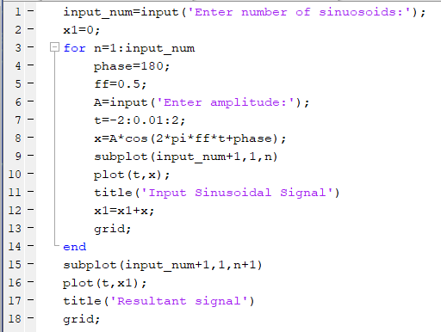

**Output / Graphs / Plots / Results:**

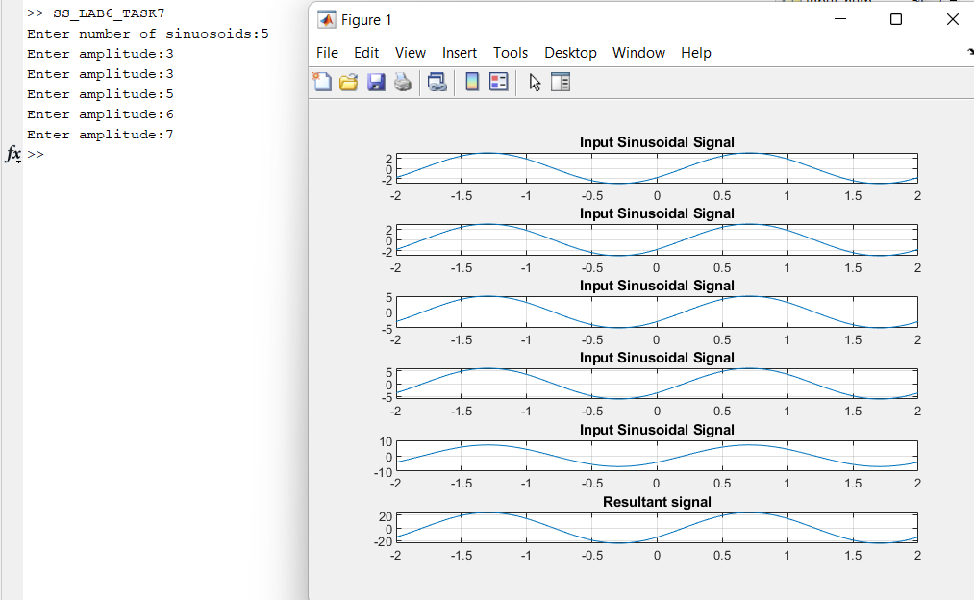

**Discussion and Conclusion:**

Hence we can compare sinousoidals in MATLAB.

## Task # 08:

Write a general program that takes ‘n’ sinusoids from user of same amplitude and phase with varying frequencies. Take each frequency from user on run time. Plot the individual sinusoids & the resultant using subplot function on same figure. Do perform proper labeling. Note: Take the amplitude and phase given in example of case 3. Run the code for different values of n and state the result on paper.

**Problem Analysis:**

We often need to compare various sinusoids with varying frequency. We can do that in MATLAB.

**Algorithm:**

* Take in no, of sinousoidals.
* Input their varying parameters.
* Create these sinousoidals and subplot them.

**Code:**

*input_num=input('Enter number of sinuosoids:');*

*x1=0;*

*for n=1:input_num*

*A=5;*

*phase=0;*

*f=input('Enter frequency:');*

*x=A*sin(2*pi*f*t+phase);*

*subplot(input_num+1,1,n)*

*plot(t,x)*

*title('Input Sinosoid')*

*x1=x1+x;*

*grid;*

*end*

*subplot(input_num+1,1,n+1)*

*plot(t,x1)*

*title('Resultant Sinusoid')*

**Code SS:**

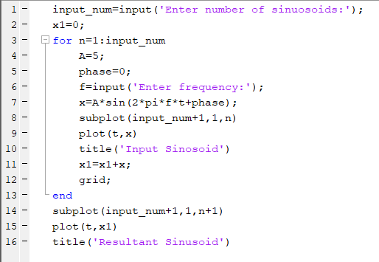

**Output / Graphs / Plots / Results:**

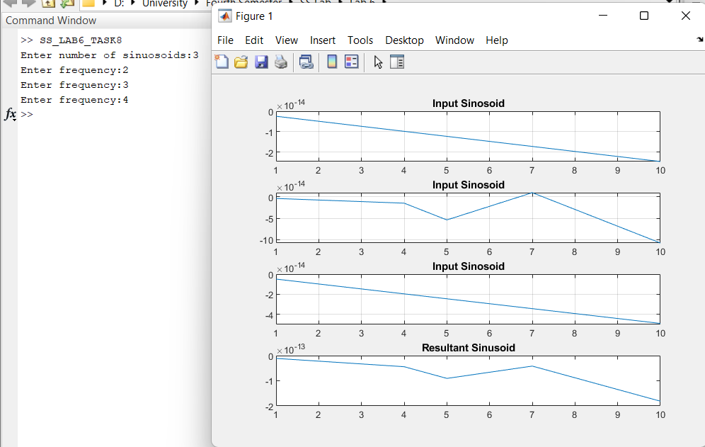

**Discussion and Conclusion:**

Hence we can compare sinousoidals in MATLAB.

## Task # 09:

Write a general program that takes ‘n’ sinusoids from user of same amplitude and frequency with varying phases. Take each phase from user on run time. Plot the individual sinusoids & the resultant using subplot function on same figure. Do perform proper labeling. Note: Take the amplitude and frequency given in example of case 4. Run the code for different values of n and state the result on paper

**Problem Analysis:**

We often need to compare various sinusoids. We can do that in MATLAB.

**Algorithm:**

* Input no of sinousoidsals.
* Create those sinousoidsals with user inout various phase shifts.
* Subplot all signals.

**Code:**

*input_num=input('Enter number of sinuosoids:');*

*x1=0;*

*t=1:10;*

*for n=1:input_num*

*f=3;*

*A=5;*

*phase=input('Enter phase shift');*

*x=A*sin(2*pi*f*t+phase);*

*subplot(input_num+1,1,n)*

*plot(t,x)*

*title('Input Sinosoid')*

*x1=x1+x;*

*grid;*

*end*

*subplot(input_num+1,1,n+1)*

*plot(t,x1)*

*title('Resultant Sinusoid')*

**Code SS:**

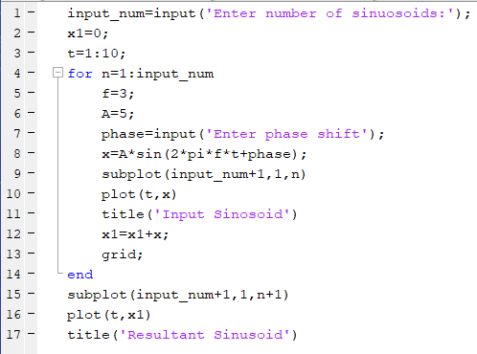

**Output / Graphs / Plots / Results:**

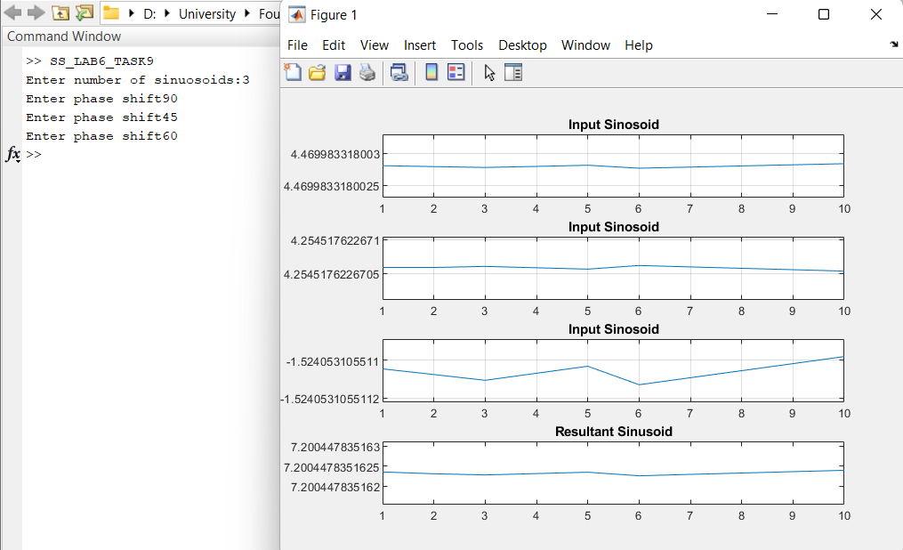

**Discussion and Conclusion:**

We can easily compare different sinousidals in MATLAB.